**BVC:Transport**

**A Project Report Submitted in partial fulfilment of the requirements for the award of the degree of**

**BACHELOR OF TECHNOLOGY**

**in**

**COMPUTER SCIENCE AND ENGINEERING**

**Submitted By**

**Sisindri P. 18221A0576**

**Praveen p. 18221A0578**

**Sai Prasad P. 18221A0580**

**Lokesh.T 19225A0511**

**Under the Supervision of Mr.k.srinivas,**

**M.Tech. ph.D,**

**Associate Professor**



**DEPARTMENT OF COMPUTER SCIENCE AND ENGINEERING**

**BONAM VENKATA CHALAMAYYA ENGINEERING COLLEGE**

**(AUTONOMOUS)**

(Approved by A.I.C.T.E, New Delhi & Permanently Affiliated to J. N.T.U.K, Kakinada)

(Accredited by N.B.A & NAAC with „A‟ Grade)

**ODALAREVU – 533210**

**2018-22**

**BONAM VENKATA CHALAMAYYA ENGINEERING COLLEGE**

**(AUTONOMOUS)**

(Approved by A.I.C.T.E, New Delhi & Permanently Affiliated to J. N.T.U.K, Kakinada)

(Accredited by N.B.A & NAAC with „A‟ Grade)

**DEPARTMENT OF COMPUTER SCIENCE AND ENGINEERING**



## CERTIFICATE

This is to certify that the project work entitled **“BVC:Transport”** is being submitted for the partial fulfilment of the requirements for the award of the degree of **Bachelor of Technology** in **Computer Science and Engineering**, at **BVC Engineering College**, **Odalarevu**, is a bonafide work done by **Sisindri P. (18221A0576), Praveen p.(18221A05A8),SaiPrasadP.(18221A0580),Lokesh .TN (19221A0511)** under the academic year 2018-19 and it has been found suitable for acceptance according to the requirement of University.

The results embodied in this thesis have not been submitted to any other University Institute for the award of any degree.

**Project Guide Head of the Department**

**Mr. k.srinivas , Dr.GUNAMANI JENA**

**M.Tech, ph.D, M.E, Ph.D**

**Associate Professor Professor**

**External Examiner**

**ACKNOWLEDGEMENT**

We express our deep sense of gratitude and respect towards our guide

**Mr.k.srinivas**, **Associate Professor** of CSE Department, BVC

Engineering College, Odalarevu for his excellent guidance right from selection of the Project work. Her constant encouragement and spport has been the cause of our success in completing this thesis in the college.

We are thankful To **Dr.GUNAMANI JENA**, **Professor and Head of the Department of CSE** for facilitating, Training, providing us the counselling and support to carry out the project work.

We are also thankful to **Dr. Chandra Mouli V S A**, **Principal**, BVC Engineering

College, Odalarevu, for his support during and till the completion of the project.

We are thankful to all the **teaching and non-teaching staff** of Computer Science & Engineering Department, **Management**, BVC Engineering College, Odalarevu, and our friends for their direct and indirect help provided to us in completing the project.

Project Associates…..

**Sisindri P. (18221A0576)**

**Praveen p. (18221A0578)**

**Sai Prasad P. (18221A0580)**

**Lokesh.TN (19225A05110)**

**ABSTRACT**

**BVC Transport:** This mini project gives us information about the each and every buses routes,stops,bus update and timings etc.Actually many students face problems which bus they have to catch and in which stop they have to get down to reach their destination and sometimes students misses bus due to lack of information about college transport management and their bus timings system.Mostly new joining students don't know about buses and their routes and their destination bus and the bus stops and routes so to over come these kind of ambiguity and problems we have developed this mini-project which helps students alot to give every student information about college buses transport.

So to develop this idea ,I have chosen the C++ language as a source to complete this project. Using the different concepts of the C++ language we had written the code.Due to this mini-project BVC Transport ,provides the each and every bus driver contact number to get information about bus current status and even provides the BVC Transport Incharge and manager contacts and mails to know more information and if any problems to complaint the authority. Actually we developed this mini project as a sample of limited buses routes and other information ,if we go further more work in deep ,we can see a clear vision of app BVC Transport App which provides every student all information about college buses with advance features.

**i**

**TABLE OF CONTENTS**

**ABSTRACT i**

**TABLE OF CONTENTS ii**

**LIST OF FIGURES iii**

**CHAPTER-1**

**INTRODUCTION 1**

**CHAPTER-2**

**SYSTEM ANALYSIS 5**

2.1 PROPOSED SYSTEM

2.1.1 PURPOSE AND OBJECTIVES

2.1.2 SYSTEM DESIGN

**CHAPTER-3**

**SYSTEM SPECIFICATION 8**

3.1 FRONTEND AND FEATURES

3.1.1 BACKEND DEVELOPMENT

**CHAPTER-4**

**CODING 9**

**CHAPTER-5**

**SYSTEM TESTING 26**

CHAPTER 6

FUTURE WORK 30

REFERENCE

**ii LIST OF FIGURES**

1. **Sequence Diagram**
2. **Data Flow Diagram of System**

**iii BVC: TRANSPORT**

**CHAPTER -1**

# INTRODUCTION

**C++** is an Object Oriented Programming language but is not purely Object Oriented.

Its features like Friend and Virtual violate some of the very important OOPS features, rendering this language unworthy of being called completely Object Oriented. Its a middle level language.

**Class**: A class is like a blueprint for an object. It is the building block of C++ that lead to Object Oriented programming. It is a user defined data type, which holds its own data members and member functions, which can be accessed and used by creating an instance of that class

* An Object is an instance of a Class. When a class is defined, no memory is allocated but when it is instantiated (i.e. an object is created) memory is allocated.

**Declaring Objects:**

* When a class is defined, only the specification for the object is defined; • No memory or storage is allocated.
* To use the data and access functions defined in the class,you need to create objects.

**Inheritance in C++**

The capability of a class to derive properties and characteristics from another class is called **Inheritance**. Inheritance is one of the most important feature of Object Oriented Programming.

**Sub Class:** The class that inherits properties from another class is called Sub class or Derived Class.

**Super Class:**The class whose properties are inherited by sub class is called Base Class or Super class.



1

**Polymorphism in C++**

The word polymorphism means having many forms. In simple words, we can define polymorphism as the ability of a message to be displayed in more than one form. Real life example of polymorphism, a person at the same time can have different characteristic. Like a man at the same time is a father, a husband, an employee. So the same person posses different behavior in different situations. This is called polymorphism. Polymorphism is considered as one of the important features of Object Oriented Programming.

**Abstraction in C++**

Data abstraction is one of the most essential and important feature of object oriented programming in C++. Abstraction means displaying only essential information and hiding the details. Data abstraction refers to providing only essential information about the data to the outside world, hiding the background details or implementation.

Consider a real life example of a man driving a car. The man only knows that pressing the accelerators will increase the speed of car or applying brakes will stop the car but he does not know about how on pressing accelerator the speed is actually increasing, he does not know about the inner mechanism of the car or the implementation of accelerator, brakes etc in the car. This is what abstraction is.



2

**Dynamic Binding:**

In dynamic binding, the code to be executed in response to function call is decided at runtime. C++ has [virtual functions](https://www.geeksforgeeks.org/virtual-functions-and-runtime-polymorphism-in-c-set-1-introduction/) to support this.

**Message Passing:**

Objects communicate with one another by sending and receiving information to each other. A message for an object is a request for execution of a procedure and therefore will invoke a function in the receiving object that generates the desired results. Message passing involves specifying the name of the object, the name of the function and the information to be sent.

**Features of C++**

1. The name of C++ signifies the evolutionary nature of the changes from C. “++” is the C increment operator.

1. C++ is one of the predominant languages for the development of all kind of technical and commercial software.

1. C++ introduces Object-Oriented Programming, not present in C. Like other things,

C++ supports the four primary features of OOP: encapsulation, polymorphism, abstraction, and inheritance.

1. C++ got the OOP features from Simula67 Programming language.

1. A function is the minimum requirement for a C++ program to run.

1. C and C++ invented at same place i.e. at T bell laboratories.

1. Not purely object oriented: We can write C++ code without using classes and it will compile without showing any error message.

The language have some extensions over C, that make OOP and generic programming more convenient.

1. Many programming languages are influenced by c++, some of which include C#, Java and even newer versions of C.

9 Concept of reference variables: operator overloading borrowed from Algol 68 programming language.

10.A major reason behind success of C++ is that it supports various programming styles.

It is a multiparadigm programming language that not only supports OOP paradigm but also many other paradigms.



3

**Following are the advantages of C++:**

* 1. C++ is a highly portable language and is often the language of selection for multidevice, multi-platform app development.
  2. C++ is an object-oriented programming language and includes concepts like classes, inheritance, polymorphism, data abstraction, and encapsulation which allow code reusability and makes programs very maintainable.
  3. C++ use multi-paradigm programming. The Paradigm means the style of programming .paradigm concerned about logics, structure, and procedure of the program. C++ is multi-paradigm means it follows three paradigm Generic, Imperative, Object Oriented.
  4. It is useful for the low-level programming language and very efficient for general purpose.
  5. C++ gives the user complete control over memory management. This can be seen both as an advantage and a disadvantage as this increases the responsibility of the user to manage memory rather than it being managed by the Garbage collector.
  6. The wide range of applications: From GUI applications to 3D graphics for games to real-time mathematical simulations, C++ is everywhere.
  7. C++ has a huge community around it. Community size is important, because the larger a programming language community is, the more support you would be likely to get. C++ is the 6th most used and followed tag on StackOverflow and GitHub.
  8. C++ has a very big job market as it is used in various industries like finance, app development, game development, Virtual reality, etc.
  9. C++'s greatest strength is how scalable it could be, so apps that are very resource intensive are usually built with it. As a statically written language, C++ is usually more performant than the dynamically written languages because the code is typechecked before it is executed.
  10. Compatibility with C: C++ is compatible with C and virtually every valid C program is a valid C++ program.



4

**BVC: TRANSPORT**

## CHAPTER -2 SYSTEM ANALYSIS

**2.1 Proposed System:**

This project proposes is main advantage for students. This project can make the information about college buses to help students. It involves a faster searching process while in the process of accessing required information of college bus timings and other data. Although, this BVC: Transport does not use GUI programming, it is good enough to get the required information from Console Interface. In this system, user can access his information from different options available. Since BVC students are facing many problems according to transport system ,Hence this “BVC:Transport” can act as a best system to know about bus timings and other information of bvc transport.

**2.1.1 PURPOSE AND OBJECTIVES A. PURPOSE:**

The purpose is to design a console application that allows the students to know about more information about bvc transport facilities.



5

**B. OBJECTIVES:**

* Providing interface to Students
* Decrease the time required to access the information

**2.1.2 SYSTEM DESIGN**

This deals with data flow diagram, and detailed design process of the front and back end design of “BVC: Transport”



**DATA FLOW DIAGRAM (DFD):**

A DFD is commonly used during problem analysis. It represents the flow of data from a system. Flow of data from different processes in the system are shown in the following Data Flow Diagram i.e fig.1 , fig.2 and fig.3



6

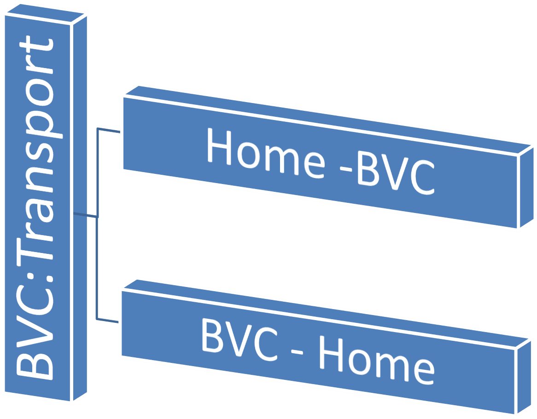

**Fig-1**

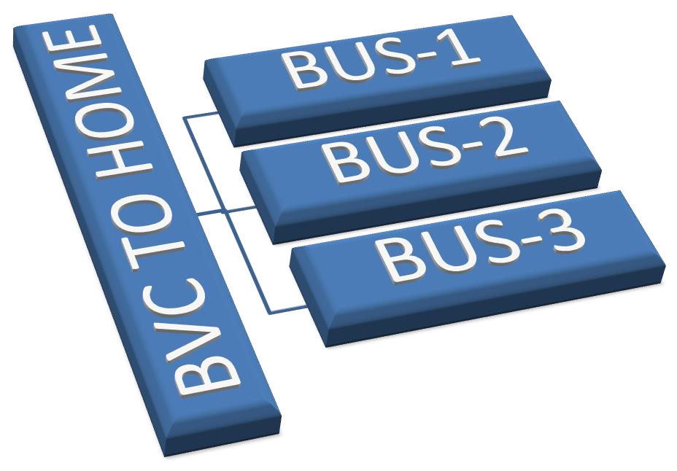

**Fig-1**

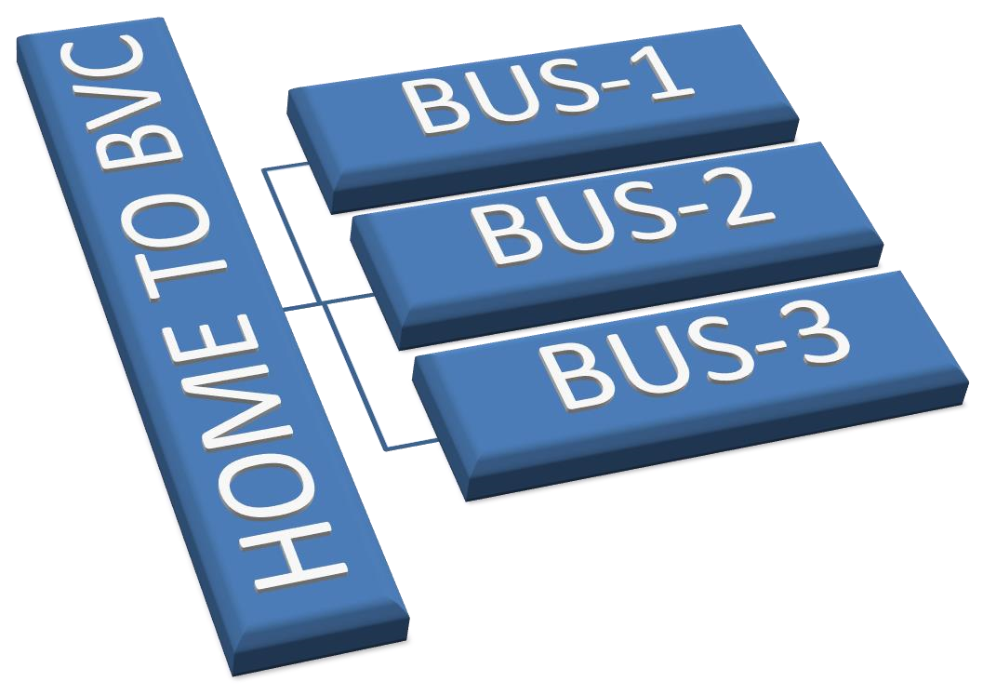



**Fig-3**

**BVC: TRANSPORT**

**CHAPTER**

**-**

**3**



## SYSTEM SPECIFICATION

### 3.1 Frontend and Features

Since “BVC:Transport” is a console application, it won‟t consist of GUI options. The command line like black window will be open when one starts this supplication. A console application simple but useful tool for different purposes, but they don‟t have colourful frontend features.

The Features user will be given to display are:

The Home screen options are:

1. **BVC to Home**
2. **Home to BVC**
3. **Exit**

**Specification:**

**The Input Option 1 will in return have following options:**



8

For Bus 1 we have:

1. **Odalarevu Center**
2. **Bendamuralamka**
3. **Allavaram**
4. **Amalapuram**

In the same way it has four stops for each bus as a sample and similarly for second bus and third bus also.

**The Input Option 2 will in return have following options:**

For Bus 1 we have –

1. **amalapuram**
2. **allavaram**
3. **Bendamuralanka**
4. **Odalarevucenter**

So in the same way we have four stops for each bus as a sample similarly for second bus and third bus also.

**BVC**

**:**

**Transport**



**CHAPTER -4**

## CODING

**#include<iostream> #include<cstdlib> using namespace std; class bus1{**

**public: int initial; int destination; int firststop; int secondstop; int thirdstop;**

**string ini,des,first,second,third;**

**bus1(){ initial=0; firststop=1; secondstop=2; thirdstop=3; destination=4;**

**ini="BVC";**

**des="Amalapuram";**

**first="Odalaravu Centre"; second="Bendamuralanka"; third="Allavaram";**

**}**

**bus1(int i) {**

**initial=1; firststop=2; secondstop=3;**

**thirdstop=4;**

**destination=0;**

**des="BVC";**

**ini="Amalapuram"; first="Allavaram"; second="Bendamuralanka"; third="Odalarava Centre";**

**}**

**};**



10

**class bus2{**

**public: int initial; int destination; int firststop; int secondstop; int thirdstop;**

**string ini,des,first,second,third;**

**bus2(){ initial=0; firststop=5; secondstop=6;**

**thirdstop=7;**

**destination=8;**

**ini="BVC"; des="D.Gannavaram";**

**first="Kommarigiripattanam";**

**second="Monganda";**

**third="Machavaram";**

**}**

**bus2(int i){**

|  |  |
| --- | --- |
|  | **initial=5;** |
|  | **firststop=6;** |
|  | **secondstop=7;** |
|  | **thirdstop=8;** |
|  | **destination=0;** |
|  | **des="BVC";** |
|  | **ini="D.Gannavaram";** |
|  | **first="Machavaram";** |
|  | **second="Monganda";** |
|  | **third="Kommarigiripattanam";** |
| **}** |  |

**};**

**class bus3{**

**public: int initial; int destination; int firststop; int secondstop;**

**int thirdstop;**

**string ini,des,first,second,third;**

**bus3(){**

**initial=0; firststop=9; secondstop=10;**

**thirdstop=11;**

**destination=12;**

**ini="BVC";**

**des="Ravulapalem"; first="Highschool"; second="Redbridge"; third="Clocktower";**

**}**

**bus3(int i){**

**initial=9; firststop=10; secondstop=11; thirdstop=12; destination=0; ini="Ravulapalem";**



12

**des="BVC";**

**first="Clocktower"; second="Redbridge"; third="Highschool";**

**}**

**};**

**int main(){**

**cout<<""<<endl;**

**int i;**

**for(i=0;i<53;i++) {**

**cout<<"*@@*";**

**}**

**cout<<""<<endl; cout<<""<<endl;**

**cout<<"\t\t\t\t\t\t\t\t\t\t\t *** BVC COLLEGE TRANSPORT *** "<<endl;**

**cout<<""<<endl; cout<<""<<endl;**

**cout<<" ## BUS TIMINGS : Morning - 6:00am to 9:00am"<<endl; cout<<" ## BUS TIMINGS : Evening - 4:00pm to 7:00pm"<<endl;**

**cout<<""<<endl; cout<<""<<endl;**

**cout<<" ## BUSES from BVC to Destination(HOME)"<<endl;**

**cout<<""<<endl;**

**cout<<" -> STOP 1 ->STOP 2 ->STOP 3 -**

**>LAST STOP"<<endl;**

**cout<<""<<endl;**

**cout<<" ## BUS1 :: 1=odalarevucenter 2=bendamuralanka**

**3=allavaram 4=amalapuram "<<endl;**

**cout<<" ## BUS2 :: 5=komagiripatnam 6= munganda 7= machavaram 8=dgannavaram "<<endl;**

**cout<<" ## BUS3 :: 9= highschool 10= redbridge 11=clocktower**

**12=ravulapalem "<<endl;**

**cout<<""<<endl; cout<<""<<endl;**

**cout<<" ## BUSES from Destination(HOME) to BVC"<<endl;**

**cout<<""<<endl;**

13

**cout<<" ->STOP 1 ->STOP 2 ->STOP 3 -**

**>LAST STOP"<<endl;**

**cout<<""<<endl;**

**cout<<" ## BUS1 :: 1=amalapuram 2=allavaram**

**3=bendamuralanka 4=odalarevucenter "<<endl;**



**cout<<" ## BUS2 :: 5=dgannavaram 6=machavaram**

**7=munganda 8=komagiripatnam "<<endl;**

**cout<<" ## BUS3 :: 9=ravulapalem 10=clocktower 11= redbridge**

**12= highschool "<<endl;**

**cout<<""<<endl; cout<<""<<endl;**

**for(i=0;i<53;i++) {**

**cout<<"*@@*";**

**}cout<<"\n";**

**int destination;**



14

**int op; while(1) { cout<<"Enter Your Route 1.BVC to HOME"<<endl;**

**cout<<" 2.HOME to BVC"<<endl; cout<<" 3.EXIT"<<endl;**

**cin>>op;**

**if(op == 1) {**

**bus1 route1; bus2 route2; bus3 route3;**

**cout<<"Enter your Destination Place : "; cin>>destination; while(destination<=12) { if(destination==route1.destination){ cout<<"Bus No : AP 07 RJ 8585 "<<endl; cout<<"STOP : "<<route1.des<<endl; cout<<"Arrival Time : 4:30 PM"<<endl; cout<<"Departure Time : 4:40 PM"<<endl; cout<<"Driver Ph : 7732076050"<<endl; cout<<"Route No : 7"<<endl; cout<<"Destination Time: 5:30 PM"<<endl;**



**break;**

**}**

**else if(destination==route1.firststop){**

**cout<<"Bus No : AP 07 RJ 8585"<<endl; cout<<"STOP : "<<route1.first<<endl; cout<<"Arrival Time : 4:30 PM"<<endl; cout<<"Departure Time : 4:40 PM"<<endl; cout<<"Driver Ph : 7732076050"<<endl; cout<<"Route No : 7"<<endl; cout<<"Destination Time: 5:40 PM"<<endl;**

**break;**

**}**

**else if(destination==route1.secondstop){ cout<<"Bus No : AP 07 RJ 8585"<<endl; cout<<"STOP : "<<route1.second<<endl; cout<<"Arrival Time : 4:30 PM"<<endl;**

**cout<<"Departure Time : 4:40 PM"<<endl;**

**cout<<"Driver Ph : 7732076050"<<endl;**

**cout<<"Route No : 7"<<endl;**

15

**cout<<"Destination Time: 5:50 PM"<<endl;**

**break;**

**}**

**else if(destination==route1.thirdstop){ cout<<"Bus No : AP 07 RJ 8585"<<endl; cout<<"STOP : "<<route1.third<<endl; cout<<"Arrival Time : 4:30 PM"<<endl; cout<<"Departure Time : 4:40 PM"<<endl; cout<<"Driver Ph : 7732076050"<<endl; cout<<"Route No : 7"<<endl; cout<<"Destination Time: 5:57 PM"<<endl;**



**break;**

**}**

**else if(destination==route2.destination){ cout<<"Bus No : AP 65 RJ 5650"<<endl; cout<<"STOP : "<<route2.des<<endl; cout<<"Arrival Time : 4:30 PM"<<endl; cout<<"Departure Time : 4:44 PM"<<endl; cout<<"Driver Ph : 6281325936"<<endl; cout<<"Route No : 10"<<endl; cout<<"Destination Time: 5:55 PM"<<endl;**

**break;**

**}**

**else if(destination==route2.firststop){**

**cout<<"Bus No : AP 65 RJ 5650"<<endl; cout<<"STOP : "<<route2.first<<endl; cout<<"Arrival Time : 4:30 PM "<<endl; cout<<"Departure Time : 4:44 PM"<<endl;**



16

**cout<<"Driver Ph : 6281325936"<<endl; cout<<"Route No : 10"<<endl; cout<<"Destination Time: 6:00 PM"<<endl;**

**break;**

**}**



**else if(destination==route2.secondstop){ cout<<"Bus No : AP 65 RJ 5650"<<endl; cout<<"STOP :"<<route2.second<<endl; cout<<"Arrival Time : 4:30 PM"<<endl; cout<<"Departure Time : 4:44 PM"<<endl; cout<<"Driver Ph : 6281325936"<<endl; cout<<"Route No : 10"<<endl; cout<<"Destination Time: 6:10 PM"<<endl;**

**break;**

**}**

**else if(destination==route2.thirdstop){ cout<<"Bus No : AP 65 RJ 5650"<<endl; cout<<"STOP : "<<route2.third<<endl; cout<<"Arrival Time : 4:30 PM "<<endl; cout<<"Departure Time : 4:44 PM"<<endl; cout<<"Driver Ph : 6281325936"<<endl; cout<<"Route No : 10"<<endl; cout<<"Destination Time: 6:30 PM"<<endl;**

**break;**

**}**

**else if(destination==route3.destination){**

**cout<<"Bus No : AP 91 RJ 5630"<<endl;**

**cout<<"STOP : "<<route3.des<<endl;**

17

**cout<<"Arrival Time : 4:30 PM "<<endl; cout<<"Departure Time : 4:50 PM"<<endl; cout<<"Driver Ph : 8297932037"<<endl; cout<<"Route No : 14"<<endl; cout<<"Destination Time: 5:30 PM"<<endl;**



**break;**

**}**

**else if(destination==route3.firststop){**

**cout<<"Bus No : AP 91 RJ 5630"<<endl; cout<<"STOP : "<<route3.first<<endl; cout<<"Arrival Time : 4:30 PM "<<endl; cout<<"Departure Time : 4:50 PM"<<endl; cout<<"Driver Ph : 8297932037"<<endl; cout<<"Route No : 14"<<endl; cout<<"Destination Time: 6:30 PM"<<endl;**

**break;**

**}**

**else if(destination==route3.secondstop){ cout<<"Bus No : AP 91 RJ 5630"<<endl; cout<<"STOP : "<<route3.second<<endl; cout<<"Arrival Time : 4:30 PM "<<endl; cout<<"Departure Time : 4:50 PM"<<endl; cout<<"Driver Ph : 8297932037"<<endl; cout<<"Route No : 14"<<endl; cout<<"Destination Time: 6:40 PM"<<endl;**

**break;**

**}**

**else if(destination==route3.thirdstop){**

18

**cout<<"Bus No : AP 91 RJ 5630 "<<endl; cout<<"STOP : "<<route3.third<<endl; cout<<"Arrival Time : 4:30 PM "<<endl; cout<<"Departure Time : 4:50 PM"<<endl;**

**cout<<"Driver Ph : 8297932037"<<endl;**



**cout<<"Route No : 14"<<endl; cout<<"Destination Time: 6:50 PM"<<endl;**

**break;**

**}**

**else{**

**cout<<"For Help And Complaints Contact :: Mr.Chalamayya"<<endl; cout<<"For More Information Contact :: 1410333888"<<endl; cout<<"Mail : bvctransport@gmail.com"<<cout;**

**break;**

**}**

**}**

**}else if(op ==2){**

**bus1 route1(1); bus2 route2(1); bus3 route3(1);**

**cout<<"Enter your pickup point : "; cin>>destination; while(destination<=12) {**

**if(destination==route1.initial){**

**cout<<"Bus No : AP 15 RS 5070"<<endl;**

19

**cout<<"Stop : "<<route1.ini<<endl; cout<<"Arrival Time : 7:20 AM"<<endl; cout<<"Departure Time : 7:25"<<endl;**

**cout<<"Driver Ph : 9381477418"<<endl;**

**cout<<"Route No : 1"<<endl;**

**cout<<"Destination Time: 8:50 AM"<<cout;**

**break;**

**}**

**else if(destination==route1.firststop){ cout<<"Bus No : AP 15 RS 5070"<<endl; cout<<"Stop : "<<route1.first<<endl;**

**cout<<"Arrival Time : 7:55 AM"<<endl; cout<<"Departure Time : 7:59 AM"<<endl; cout<<"Driver Ph : 9381477418"<<endl; cout<<"Route No : 1"<<endl; cout<<"Destination Time: 8:50 AM"<<cout;**

**break;**

**}**

**else if(destination==route1.secondstop){ cout<<"Bus No : AP 15 RS 5070"<<endl; cout<<"Stop : "<<route1.second<<endl; cout<<"Arrival Time : 8:10 AM"<<endl; cout<<"Departure Time : 8:15 AM"<<endl; cout<<"Driver Ph : 9381477418"<<endl; cout<<"Route No : 1"<<endl;**

**cout<<"Destination Time: 8:50 AM"<<cout;**

**break;**

**}**



20

**else if(destination==route1.thirdstop){ cout<<"Bus No : AP 15 RS 5070"<<endl; cout<<"Stop : "<<route1.third<<endl; cout<<"Arrival Time : 8:30 AM"<<endl; cout<<"Departure Time : 8:35 AM"<<endl; cout<<"Driver Ph : 9381477418"<<endl; cout<<"Route No : 1"<<endl; cout<<"Destination Time: 8:50 AM"<<cout;**



**break;**

**}**

**else if(destination==route2.initial){**

**cout<<"Bus No : AP 17 VP 5750"<<endl; cout<<"Stop : "<<route2.ini<<endl; cout<<"Arrival Time : 6:30 AM"<<endl; cout<<"Departure Time : 6:35 AM"<<endl; cout<<"Driver Ph : 6302958707"<<endl; cout<<"Route No : 4"<<endl; cout<<"Destination Time: 8:55 AM"<<cout;**



21

**break;**

**}**

**else if(destination==route2.firststop){**

**cout<<"Bus No : AP 17 VP 5750"<<endl; cout<<"Stop : "<<route2.first<<endl; cout<<"Arrival Time : 6:50 AM"<<endl; cout<<"Departure Time : 6:55 AM"<<endl; cout<<"Driver Ph : 6302958707"<<endl; cout<<"Route No : 4"<<endl; cout<<"Destination Time: 8:55 AM"<<cout; break;**

**}**

**else if(destination==route2.secondstop){**

**cout<<"Bus No : AP 17 VP 5750"<<endl;**

**cout<<"Stop : "<<route2.second<<endl;**

**cout<<"Arrival Time : "<<endl; cout<<"Departure Time : "<<endl; cout<<"Driver Ph : 6302958707"<<endl; cout<<"Route No : 4"<<endl; cout<<"Destination Time: 8:55 AM"<<cout;**

**break;**

**}**

**else if(destination==route2.thirdstop){ cout<<"Bus No : AP 17 VP 5750"<<endl; cout<<"Stop : "<<route2.third<<endl; cout<<"Arrival Time : 7:20 AM"<<endl; cout<<"Departure Time : 7:25 AM"<<endl; cout<<"Driver Ph : 6302958707"<<endl; cout<<"Route No : 4"<<endl; cout<<"Destination Time: 8:55 AM"<<cout;**



22

**break;**

**}**

**else if(destination==route3.initial){ cout<<"Bus No : "<<endl; cout<<"Stop : "<<route3.ini<<endl;**

**cout<<"Arrival Time : 8:00 AM"<<endl;**

**cout<<"Departure Time : 8:10 AM"<<endl; cout<<"Driver Ph : 9100453373"<<endl; cout<<"Route No : 3"<<endl;**

**cout<<"Destination Time: 9:00 AM"<<cout;**

**break;**

**}**

**else if(destination==route3.firststop){**

**cout<<"Bus No : AP 15 RR 5970"<<endl; cout<<"Stop : "<<route3.first<<endl;**

**cout<<"Arrival Time : 6:00 AM"<<endl; cout<<"Departure Time : 6:10 AM"<<endl; cout<<"Driver Ph : 9100453373"<<endl; cout<<"Route No : 3"<<endl; cout<<"Destination Time: 9:00 AM"<<cout;**

**break;**

**}**



23

**else if(destination==route3.secondstop){ cout<<"Bus No : AP 15 RR 5970"<<endl; cout<<"Stop : "<<route3.second<<endl; cout<<"Arrival Time : 6:50 AM"<<endl; cout<<"Departure Time : 7:00 AM"<<endl; cout<<"Driver Ph : 9100453373"<<endl; cout<<"Route No : 3"<<endl; cout<<"Destination Time: 9:00 AM"<<cout;**

**break;**

**}**

**else if(destination==route3.thirdstop){**

**cout<<"Bus No : AP 15 RR 5970"<<endl;**

**cout<<"Stop : "<<route3.third<<endl; cout<<"Arrival Time : 7:30 AM"<<endl; cout<<"Departure Time : 7:40 AM"<<endl; cout<<"Driver Ph : 9100453373"<<endl; cout<<"Route No : 3"<<endl;**

**cout<<"Destination Time: 9:00 AM"<<cout;**

**break;**

**}**

**else{**

**cout<<"For Help and Complaints Contact :: Mr.Challamyya "<<endl; cout<<"For More Information Contact :: 1410033388"<<endl; cout<<"Mail : bvctransport@gmail.com"<<cout;**

**break;**

**}**



24

**} }**

**else if(op==3) {**

**exit(0);**

**}**

**}**

**}**

**BVC:Transport**

**CHAPTER -5**

## SYSTEM TESTING

**Home Page**

The System starts with Home page, where user can see various functionalities. The following figure shows the Home page.



25

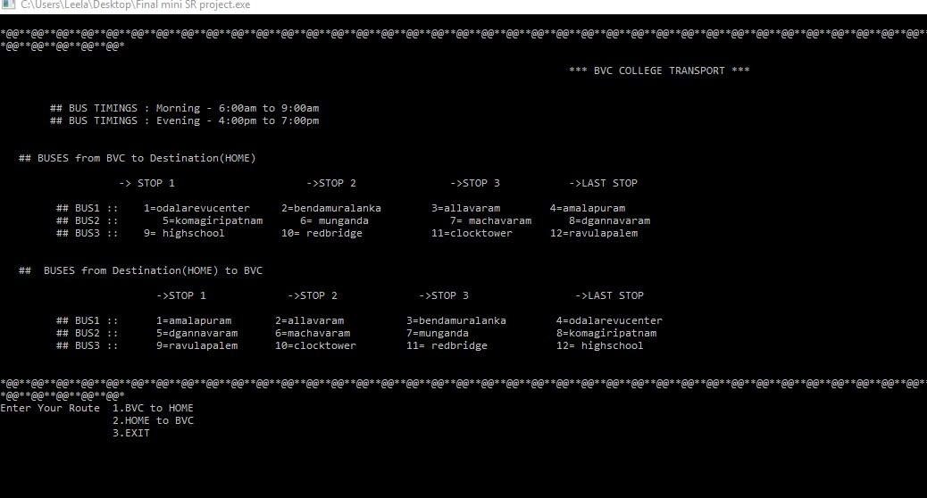

Search for Bus1 From BVC to Home**:**

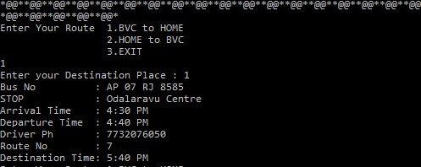

:



26

Search for Bus2 From BVC to Home:

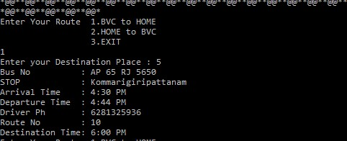

26

Search for Bus3 From BVC to Home :

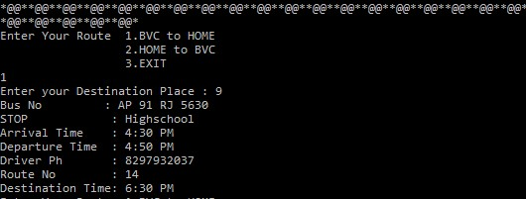

Search for Bus1 From Home to BVC :



28

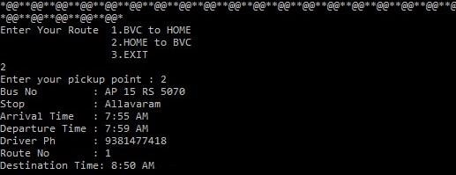

Search for Bus2 From Home to BVC:

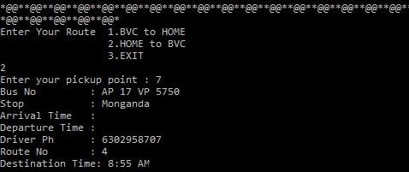

Search for Bus3 From BVC to Home:



29

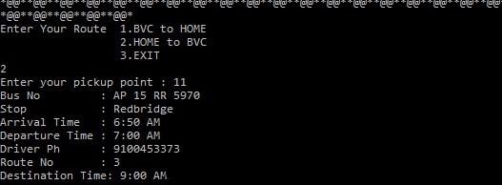

**BVC:Transport**

**CHAPTER -6**



# FUTURE WORK

**Database Connectivity:** This System will work effectively, when it is connected with Database. The future work includes this addition to the project.

**GUI Application:** The application looks user-friendly and attractive, if GUI elements are added. The future work includes this addition to the project



29

### References

1. [https://www.geeksforgeeks.org](https://www.geeksforgeeks.org/)



30

1. jbit:Transport Team